**Compiler Theory**

**Team: 40**

|  |  |  |
| --- | --- | --- |
| Name | ID | Section |
| سيف الدين وائل السيد نصر حجاب | 20201700390 | 4 |
| سيف الدين سامر عصمت احمد | 20201700382 | 4 |
| سيف الدين سيد ابراهيم سيد عمران | 20201700383 | 4 |
| سيف عز الدين احمد السيد | 20201700393 | 4 |
| احمد مجدى عبد الصادق عفيفى | 20201700066 | 1 |

**1-Number**

**Regular expression of number in tiny language :**

[0-9] [0-9]* | . [0-9] [0-9]* **OR** [0-9]+ | . [0-9]+

* The first part for integer number
* The second part for float number

**DFA simulation :**

[0-9]

[0-9]

[0-9]

Q4

Q2

Q3

Start

.

Q1

[0-9]

**NFA (THOMPSON) simulation**

ε

[0-9]

**ε**

[0-9]

.

ε

ε

ε

ε

ε

**ε**

**ε**

[0-9]

ε

ε

Start

**2-String**

**Regular Expression**

\"([a-z]|[A-Z]|[0-9]|\ |\t|\n|(.)|^(\"))*\"

**DFA**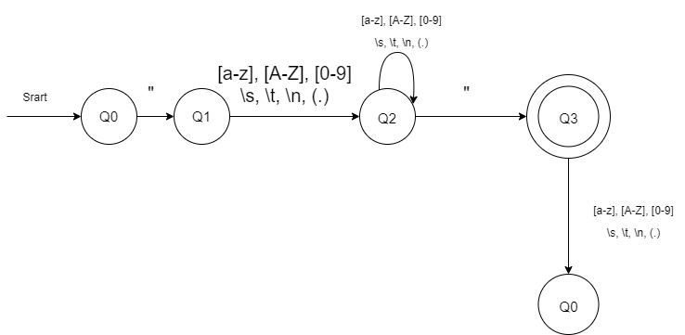

**Thomson Construction**

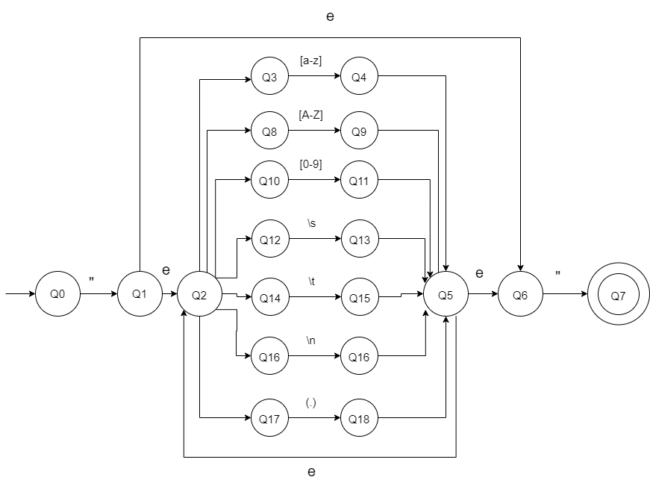

**DFA subset construction**

|  |  |  |  |  |  |  |  |  |  |
| --- | --- | --- | --- | --- | --- | --- | --- | --- | --- |
| **DFA** | **NFA** | **“** | **[a-z]** | **[A-Z]** | **[0-9]** | **\s** | **\t** | **\n** | **(.)** |
| **D0** | ->Q0 | 1,2,3,6,8,10 12,14,16,17 | -- | -- | -- | -- | -- | -- | -- |
| **D1** | 1,2,3,6,8,10 12,14,16,17 | 7* | 1,2,3,4,5,6,8 10,12,14,16,17 | 1,2,3,5,6,8,9,10  12,14,16,17 | 1,2,3,5,6,8,10,11 12,14,16,17 | 1,2,3,5,6,8,10,12,13,14,16,17 | 1,2,3,5,6,8,10,12,14,15,16,17 | 1,2,3,5,6,8,10,12,14,16,16’,17 | 1,2,3,5,6,8,10,12,14,16,17,18 |
| **--** | -- | -- | -- | -- | -- | -- | -- | -- | -- |
| **D2** | 1,2,3,4,5,6,8 10,12,14,16,17 | 7* | 1,2,3,4,5,6,8 10,12,14,16,17 | 1,2,3,5,6,8,9,10  12,14,16,17 | 1,2,3,5,6,8,10,11 12,14,16,17 | 1,2,3,5,6,8,10,12,13,14,16,17 | 1,2,3,5,6,8,10,12,14,15,16,17 | 1,2,3,5,6,8,10,12,14,16,16’,17 | 1,2,3,5,6,8,10,12,14,16,17,18 |
| **D3** | 7* | -- | -- | -- | -- | -- | -- | -- | -- |
| **D4** | 1,2,3,5,6,8,9,10  12,14,16,17 | 7* | 1,2,3,4,5,6,8 10,12,14,16,17 | 1,2,3,5,6,8,9,10  12,14,16,17 | 1,2,3,5,6,8,10,11 12,14,16,17 | 1,2,3,5,6,8,10,12,13,14,16,17 | 1,2,3,5,6,8,10,12,14,15,16,17 | 1,2,3,5,6,8,10,12,14,16,16’,17 | 1,2,3,5,6,8,10,12,14,16,17,18 |
| **D5** | 1,2,3,5,6,8,10,11 12,14,16,17 | 7* | 1,2,3,4,5,6,8 10,12,14,16,17 | 1,2,3,5,6,8,9,10  12,14,16,17 | 1,2,3,5,6,8,10,11 12,14,16,17 | 1,2,3,5,6,8,10,12,13,14,16,17 | 1,2,3,5,6,8,10,12,14,15,16,17 | 1,2,3,5,6,8,10,12,14,16,16’,17 | 1,2,3,5,6,8,10,12,14,16,17,18 |
| **D6** | 1,2,3,5,6,8,10,12,13,14,16,17 | 7* | 1,2,3,4,5,6,8 10,12,14,16,17 | 1,2,3,5,6,8,9,10  12,14,16,17 | 1,2,3,5,6,8,10,11 12,14,16,17 | 1,2,3,5,6,8,10,12,13,14,16,17 | 1,2,3,5,6,8,10,12,14,15,16,17 | 1,2,3,5,6,8,10,12,14,16,16’,17 | 1,2,3,5,6,8,10,12,14,16,17,18 |
| **D7** | 1,2,3,5,6,8,10,12,14,15,16,17 | 7* | 1,2,3,4,5,6,8 10,12,14,16,17 | 1,2,3,5,6,8,9,10  12,14,16,17 | 1,2,3,5,6,8,10,11 12,14,16,17 | 1,2,3,5,6,8,10,12,13,14,16,17 | 1,2,3,5,6,8,10,12,14,15,16,17 | 1,2,3,5,6,8,10,12,14,16,16’,17 | 1,2,3,5,6,8,10,12,14,16,17,18 |
| **D8** | 1,2,3,5,6,8,10,12,14,16,16’,17 | 7* | 1,2,3,4,5,6,8 10,12,14,16,17 | 1,2,3,5,6,8,9,10  12,14,16,17 | 1,2,3,5,6,8,10,11 12,14,16,17 | 1,2,3,5,6,8,10,12,13,14,16,17 | 1,2,3,5,6,8,10,12,14,15,16,17 | 1,2,3,5,6,8,10,12,14,16,16’,17 | 1,2,3,5,6,8,10,12,14,16,17,18 |
| **D9** | 1,2,3,5,6,8,10,12,14,16,17,18 | 7* | 1,2,3,4,5,6,8 10,12,14,16,17 | 1,2,3,5,6,8,9,10  12,14,16,17 | 1,2,3,5,6,8,10,11 12,14,16,17 | 1,2,3,5,6,8,10,12,13,14,16,17 | 1,2,3,5,6,8,10,12,14,15,16,17 | 1,2,3,5,6,8,10,12,14,16,16’,17 | 1,2,3,5,6,8,10,12,14,16,17,18 |
| **DFA** | **NFA** | **“** | **[a-z]** | **[A-Z]** | **[0-9]** | **\s** | **\t** | **\n** | **(.)** |
| **D0** | ->Q0 | D1 | -- | -- | -- | -- | -- | -- | -- |
| **D1** | 1,2,3,6,8,10 12,14,16,17 | D3 | D2 | D4 | D5 | D6 | D7 | D8 | D9 |
| **--** | -- | -- | -- | -- | -- | -- | -- | -- | -- |
| **D2** | 1,2,3,4,5,6,8 10,12,14,16,17 | D3 | D2 | D4 | D5 | D6 | D7 | D8 | D9 |
| **D3** | 7* | -- | -- | -- | -- | -- | -- | -- | -- |
| **D4** | 1,2,3,5,6,8,9,10  12,14,16,17 | D3 | D2 | D4 | D5 | D6 | D7 | D8 | D9 |
| **D5** | 1,2,3,5,6,8,10,11 12,14,16,17 | D3 | D2 | D4 | D5 | D6 | D7 | D8 | D9 |
| **D6** | 1,2,3,5,6,8,10,12,13,14,16,17 | D3 | D2 | D4 | D5 | D6 | D7 | D8 | D9 |
| **D7** | 1,2,3,5,6,8,10,12,14,15,16,17 | D3 | D2 | D4 | D5 | D6 | D7 | D8 | D9 |
| **D8** | 1,2,3,5,6,8,10,12,14,16,16’,17 | D3 | D2 | D4 | D5 | D6 | D7 | D8 | D9 |
| **D9** | 1,2,3,5,6,8,10,12,14,16,17,18 | D3 | D2 | D4 | D5 | D6 | D7 | D8 | D9 |

**DFA with subset**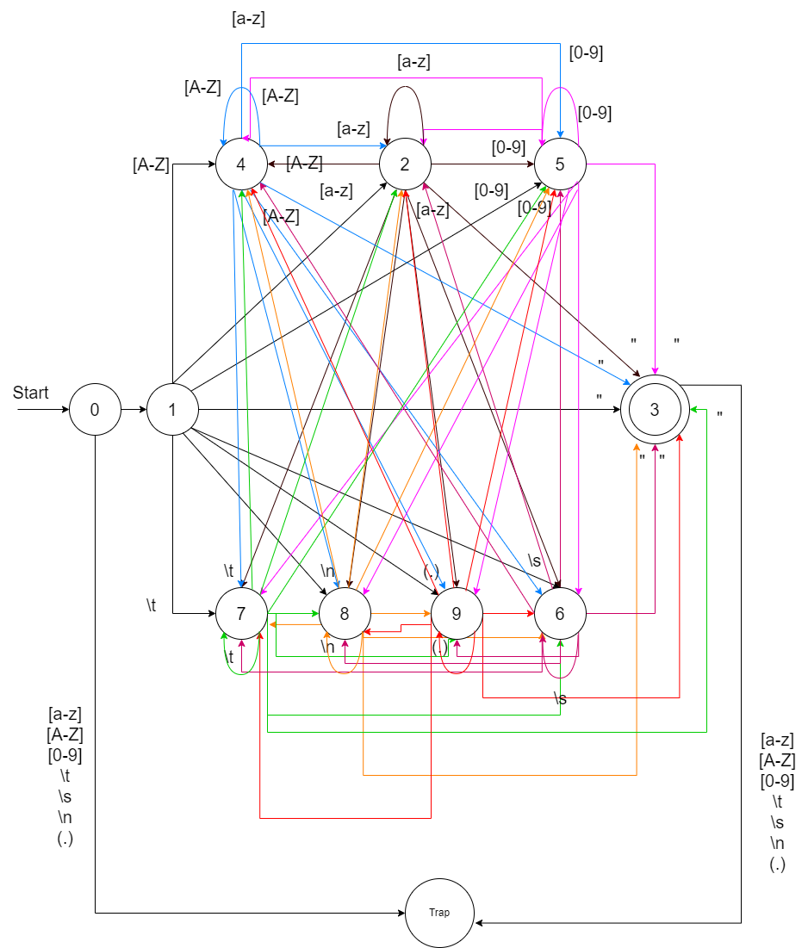

**3-Identifier**

Regular Expression: [a-z|A-Z] (**[**a-z|A-Z**]**|**[**0-9**]**)*

DFA:

[a-z|A-Z]

[0-9]

[a-z|A-Z]

start

[0-9]

[a-z|A-Z]

Ꜫ

NFA: Thompson

Ꜫ

[a-z|A-Z]

Ꜫ

start

Ꜫ

Ꜫ

Ꜫ

[a-z|A-Z]

[0-9]

Ꜫ

Ꜫ

Ꜫ

DFA subset construction:

|  |  |  |  |
| --- | --- | --- | --- |
| DFA | NFA | [a-z|A-Z] | [0-9] |
| D0 | {0} | {1} | Ø |
| D1* | {1,2,3,4,5,9}* | {6} | {7} |
| Ø | Ø | Ø | Ø |
| D2* | {3,4,5,6,8,9}* | {6} | {7} |
| D3* | {3,4,5,7,8,9}* | {6} | {7} |

|  |  |  |
| --- | --- | --- |
| DFA | [a-z|A-Z] | [0-9] |
| D0 | D1 | Ø |
| D1* | D2 | D3 |
| Ø | Ø | Ø |
| D2* | D2 | D3 |
| D3* | D2 | D3 |

[0-9]

[a-z|A-Z]

[0-9]

[a-z|A-Z]

start

[a-z|A-Z]

[0-9]

[0-9]

[a-z|A-Z]

[a-z|A-Z] ,[0-9]

Minimize DFA:

|  |  |  |
| --- | --- | --- |
| DFA | [a-z|A-Z] | [0-9] |
| D0 | D1 | Ø |
| D1* | D2 | D3 |
| Ø | Ø | Ø |
| D2* | D2 | D3 |
| D3* | D2 | D3 |

0-Equivalence: {d0, Ø } {d1, d2, d3}

1-Equivalence: {d0} {Ø} {d1, d2, d3}

2-Equivalence: {d0} {Ø} {d1, d2, d3}

|  |  |  |  |
| --- | --- | --- | --- |
| Min DFA | DFA | [a-z|A-Z] | [0-9] |
| A | {d0} | C | B |
| B | {Ø} | B | B |
| C* | {d1, d2, d3} | C | C |

[a-z|A-Z] ,[0-9]

start

[a-z|A-Z]

[a-z|A-Z] ,[0-9]

[0-9]

**4-Comments in Tiny language regex:**

**(\ / \* ( . | \s ) * \ * \ / ) |\ / \ / ([A-Za-z0-9] | . ) \***

* The first part for /**/ comments
* The second part for // comments

NFA simulation:

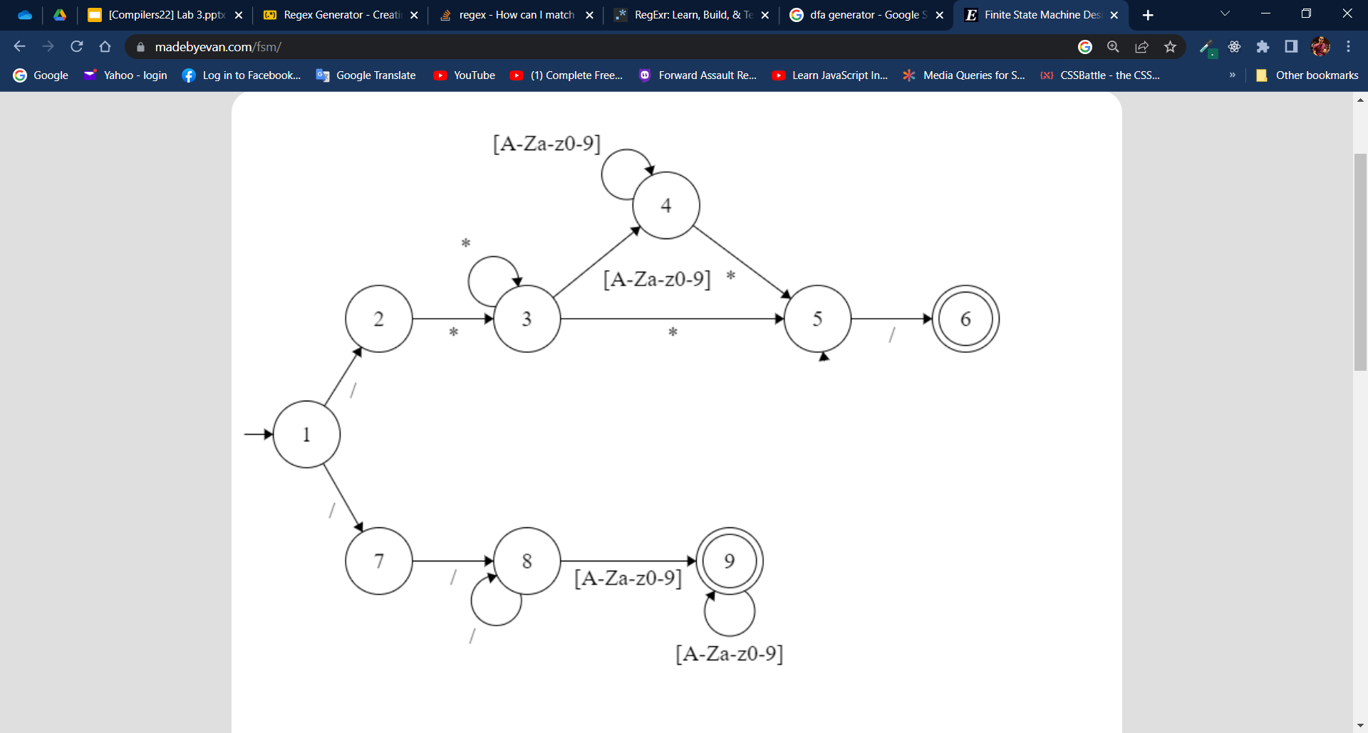

Comments in Tiny language regex:

**\ / \*( . | \s ) * \ * \ /**

DFA:

NFA using Thompson:

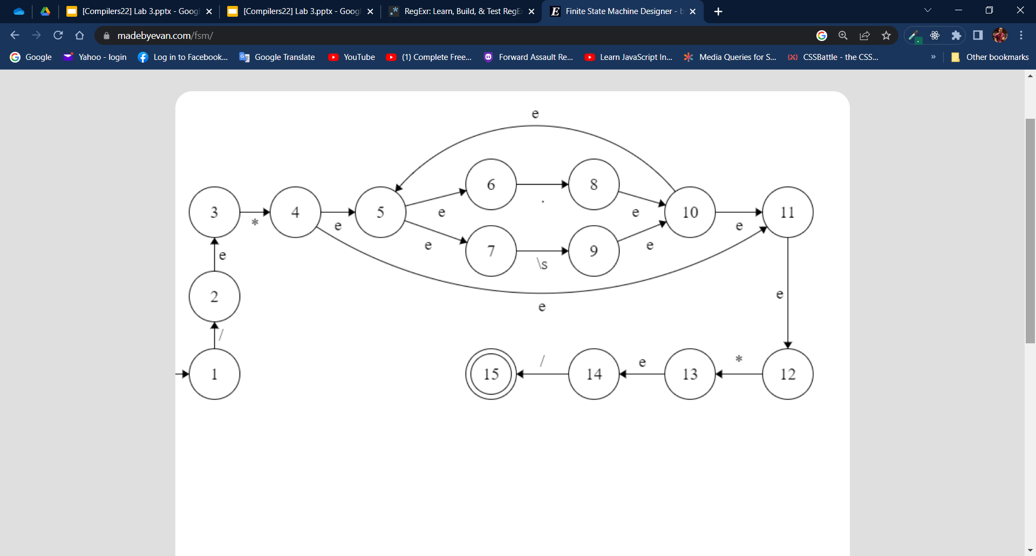

From NFA to DFA using subset constructions:

|  |  |  |  |  |  |
| --- | --- | --- | --- | --- | --- |
| DFA | NFA | / | * | . | \s |
| >D0 | {1} | {2,3} | phi | phi | phi |
| D1 | {2,3} | phi | {4,5,6,7,11} | phi | phi |
| phi | phi | phi | phi | phi | phi |
| D2 | {4,5,6,7,11} | phi | phi | {5,6,7,8,10,11,12} | {5,6,7,9,10,11,12} |
| D3 | {5,6,7,8,10,11,12} | phi | {13,14} | {5,6,7,8,10,11,12} | {5,6,7,9,10,11,12} |
| D4 | {5,6,7,9,10,11,12} | phi | {13,14} | {5,6,7,8,10,11,12} | {5,6,7,9,10,11,12} |
| D5 | {13,14} | {15} | phi | phi | phi |
| D6* | {15} | phi | phi | phi | phi |

|  |  |  |  |  |
| --- | --- | --- | --- | --- |
| DFA | / | * | . | \s |
| >D0 | D1 | Phi | Phi | Phi |
| D1 | Phi | D2 | Phi | Phi |
| D2 | Phi | Phi | D3 | D4 |
| D3 | Phi | D5 | D3 | D4 |
| D4 | Phi | D5 | D3 | D4 |
| D5 | D6* | Phi | Phi | Phi |
| D6* | Phi | Phi | Phi | Phi |

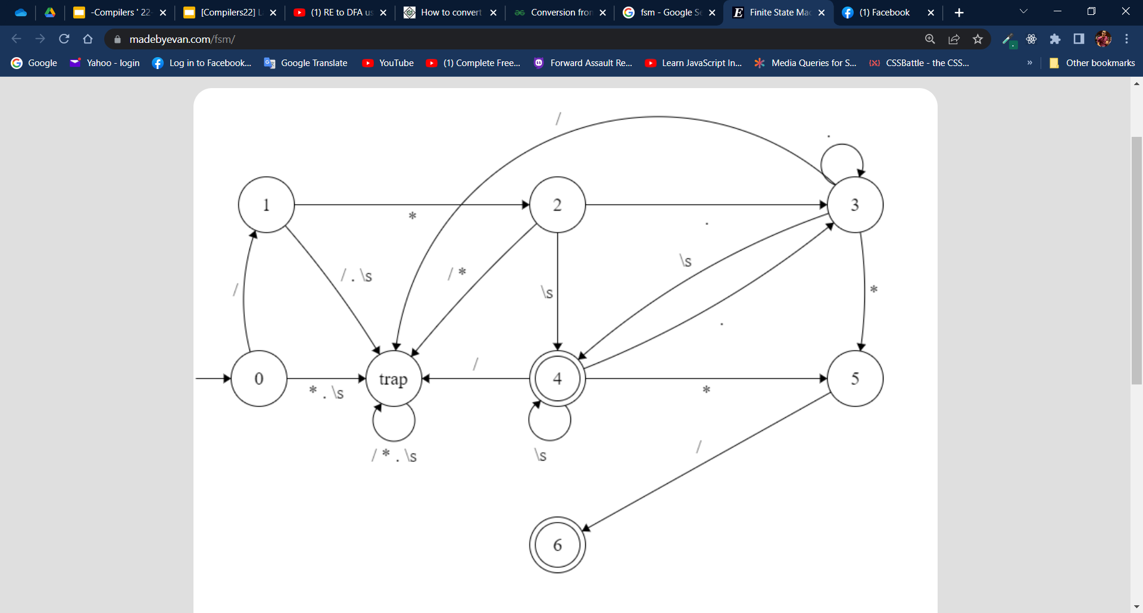

**5- Reserved words**

